Agenda

*Date: 02/08/14*

*Location: Brody Collaborative Space - Room 1045 and 1042*

*Actual Time: 1 pm - 3 pm*

*Planned Length: 2 hours*

***Silly Picture of the Week:***

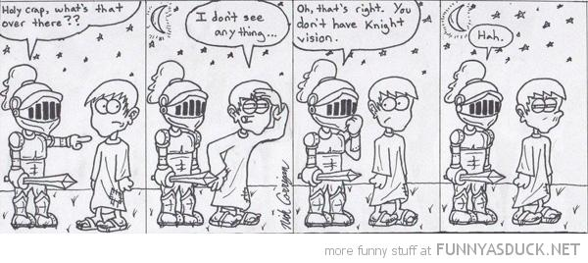

***Please add and comment on anything and everything in the agenda!***

|  |  |  |  |
| --- | --- | --- | --- |
| **Team Member(s)** | **Topic** | **Time** | **Goals** |
| Anyone | Announcements | 5 min | If any new developments have occurred the team is updated on them |
| Shannon | Weekly Deliverables | 15 min | Everyone writes their weekly deliverables for next week on the agenda |
| Shannon | Disease Struct | 20 min | Figure out what kind of info/struct to return diseases in; implement this in code |
| David and Brian | Strabismus | 30 min | push strabismus code to repo; finish strabismus code; implement proper info to return |
| Xiaomeng, Brian, Si, and Shannon | Review results of testing | 20 min | Review results of your testing with Shannon to pinpoint bugs; all bugs are fixed or assigned to someone to fix |
| Xiameng, Brian, and Si | Test with red eye photos | If there is time | Get red eye photos from the hardware team; Develop documentation to begin quantifying the accuracy of the detections for eye, pupil, white dot, and crescent (so that we can get a % accuracy for each one) |
| Arvind and Andrew | Hardware | a while | Make plan for getting lots of red eye photos ; or work with bracket/camera; or other stuffz |
| Other peoples | Other stuff |  |  |
|  |  |  |  |
|  |  |  |  |
|  |  |  |  |
|  |  |  |  |
| Everyone | Bowling! | 2 hours | At 3 pm team carpools to mira mesa lanes and goes bowling. Remember to bring socks and money for shoes and food! |
| Shannon | Recap, Next steps and Weekly Deliverables | 10 min. | Meeting progress/ goal accomplishment is recapped. Next steps are outlined so that every team member goes into next week knowing what they are expected to contribute. Weekly deliverables are updated by all team members |

# Notes

# Summary

# Weekly Deliverables

|  |  |  |
| --- | --- | --- |
| **Name** | **Deliverable(s)** | **Due By** |
| Shannon Harris | ~~Implement Disease Struct~~  ~~Review Code Errors~~ | 02/12/14  02/08/14 |
| Arvind Rao |  |  |
| Steven Yuan |  |  |
| David Chan |  |  |
| Brian Nguyen |  |  |
| John Chan |  |  |
| Mark Ma | after clicking the second horizontal button, it automatically directs to the directory of the first one |  |
| Andrew Nguyen |  |  |
| Byung-Chul In (Brian) |  |  |
| Si Li |  |  |
| Xiaomeng Wang |  |  |
| Rolando Cheung Wu |  |  |
| Shumin Gao |  |  |
| Jose A. Valdes |  |  |
|  |  |  |
|  |  |  |

# Whiteboard Pics

Front end needs to keep in mind that we need to keep track of whether the user is drawing on the left or right eye

# Useful Links

Front-End Frame Documentation: <http://docs.wxwidgets.org/2.8.11/wx_wxframe.html#wxframe>

Dropbox: <https://www.dropbox.com/sh/8nsmamaiklpvr9l/Fo5xgv4ogH>

<http://scrumy.com/DVSWinter2014>

Front-End Code for User Drawing <https://groups.google.com/forum/#!topic/wxpython-users/cDqEj_pTnjs>

Spherical Equivalent Documentation

<http://www.nfos.org/degree/opt11/module_09b.html>

Poster Session:

